Attitudes to Mental Illness

2023 summary report

October 2024

Contents

Forewords 3

1. Introduction 10

2. Background 13

2.1 The Attitudes to Mental Illness survey 13

2.2 Time to Change (2007-2021) and previous changes in stigma measures 17

3. Results 20

3.1 Attitudes, behaviour, and knowledge 20

3.2 What’s driving the marked decline in headline stigma measures? 22

3.3 Mental health vignettes and workplace attitudes 25

4. Discussion 31

5. Conclusion 35

Glossary 39

## Foreword

### Sarah Hughes, CEO Mind

Social movements around the world have been organising for decades in the collective mission to eradicate mental health stigma and discrimination, an experience that has blighted the lives of too many of us. Mind has worked with people with lived experience of mental illness, grassroots groups, and a vibrant community of allies and supporters. We have shared our stories, campaigned for equality, shared evidence-based information, challenged media stereotypes, and developed innovative services and interventions. Some might think that we have won the battle for mental health equality; others have suggested we have gone too far. We at Mind do not agree either way and this report outlines why.

The good news is that it is true we have seen a change over the decades – a steady improvement in attitudes, behaviours, understanding and knowledge around mental health. People and communities recognise that we all have mental health – a spectrum of experiences that is affected by a variety of factors such as childhood, relationships, poverty, and racism. The way we talk about mental health today is worlds away from when I started my career in the early 1990s. I can see that a space has been created in public discourse that has seen the biggest and most positive impact on those of us living with common mental health conditions such as depression and anxiety. This should be a source of pride for all of us who have been part of this collective effort. Can you hear the “but”…

The areas of most concern in this report include a drop in knowledge, declining trust in community based mental health support (such that people do not believe they will get the help they need), and changes in some of the intended behaviour metrics. These shifts strike at the heart of sustainable change and so we must remain vigilant in tackling stigma and discrimination.

The opportunity we can see in this data, though, is that there are indicators holding strong, including workplace attitudes showing improvements in perceived and actual stigma. Previous gains in tackling prejudice have largely been maintained, suggesting that the nation is ready for the next step in challenging mental health stigma. We can also see that there are green shoots of a narrowing of the stigma gap between more common mental health conditions on the one hand and serious mental illness, or the least understood experiences, on the other.

But the stark reality is that progress is fragile largely because of social and economic volatility. For example, we see a pattern over the years that public attitudes towards the most vulnerable in our society can harden during a financial crisis. It is therefore sadly unsurprising that we are reporting a mixed picture showing some of the measures tracking attitudes and behaviours going in the wrong direction.

Sadly, we suspect that things have further deteriorated since this field work was done in 2023. One of the ways we know this is that there is a downturn in the way media portray and talk about mental illness, alongside a general feeling of permissiveness for old, stigmatising tropes. Negative comments made by high-profile politicians and people in the public eye matter. That is why we will continue to challenge negative portrayals used in the public domain; it really matters. No roll back is acceptable.

We also know that mental health awareness sometimes courts controversy and there are valid questions about whether we have reached saturation point, whether society has over-medicalised human experience, whether people living with the least understood conditions have felt any significant benefit, and whether the experiences of the global majority have been overlooked in mental health discourse. This is the moment we need to answer these important challenges.

So, what next? Taking all of this into account we at Mind propose to ramp up mental health campaigning and our anti-stigma work. We have made a renewed commitment and believe that the radical change we need to see in this work to make it better for all is to centre those of us most at risk of exclusion and poor outcomes, who are discriminated and ignored. We call this approach ‘designing from the margins’. We are going deep, and we think this report tells us that the nation is ready for this next step.

### Denise Martin, lived experience volunteer and champion, Mind

I grew up through the 1970s and 80s when mental health stigma was commonplace. Mental health education was non-existent, derogatory terms were thrown around and the name-calling was horrific. There wasn’t the medical knowledge that there is nowadays either.

It was only in the 90s that conversations about mental health really started, which is when I qualified as a mental health nurse. 10 years ago, I applied for a new job. I made a pact to disclose my diagnosis on the employment form because I didn’t want to hide anymore. I was offered the job during the interview, but they withdrew the offer after they saw my form.   
   
The experience made me feel like less of a person. I could have done the job with my eyes shut, but once they learned I had bipolar that’s all they could see. After that, I experienced depression and let my registration as a nurse lapse after 28 years of practicing. I haven’t been well or confident enough to enter employment since.

I first accessed psychiatric services when I was 15 years old, but I didn’t receive a diagnosis of bipolar until I was 22. In fact, that was the first time I heard the term ‘mental health’ used. The people I spoke to didn’t believe what I was experiencing. I don’t think they had the experience to deal with me, so I was treated appallingly.

I couldn’t speak openly about my mental health, not even generally, let alone bipolar which was very misunderstood. Talking about it with friends and colleagues was simply a ‘no go’ area. My parents didn’t understand, and I have a fractured relationship with them to this day because of that. So, like many during that time, I felt alone, ashamed and afraid.

Thankfully, public knowledge of mental health has improved. Over the years I’ve seen a positive shift in how people talk about and behave around people with mental health problems. Mind and Rethink Mental Illness’s anti-stigma campaign Time to Change was a big driver in that shift. I was involved in the campaign from start to finish as a lived experience champion. I shared my story at events and campaigned to help people understand mental health better. But the end of Time to Change and the start of the pandemic halted those face-to-face conversations, and I worry the cracks are starting to show. That’s why it’s so important we take action to tackle stigma now. Otherwise, there’s a risk things will slip back to how they once were.

In a world without stigma, I wouldn’t have to hide who I am. I hope that one day we can live in a world where people with mental health problems aren’t feared or defined by their diagnosis. It's vital people with influence speak up and our new government acknowledges the damage stigma can do, examines the fear it’s routed in, and works with charities like Mind to combat it. Together, we can end stigma. But we can’t do it alone.

## 1. Introduction

Stigma is understood as ignorance about mental health problems, prejudicial attitudes around mental health, and discrimination towards people with mental health problems. Experiencing stigma is sadly part of the reality of having a mental health problem. Many people report that the stigma around mental health problems can be as bad as, or worse than, the symptoms.[1] Stigma presents a barrier accessing support, and undermines self-respect among people with mental health problems.[2]

### Are we going in the right direction?

The Attitudes to Mental Illness research is designed to give a comprehensive and detailed account of the state of the stigma around mental health in England, and to track how this has changed over time.

The latest wave of Attitudes to Mental Illness research has revealed a mixed picture of the stigma around mental health in England. Following a decade of improvement, worryingly we have seen the first marked negative shift in some topline measures of the stigma around mental health in England in recent years. Measures of mental health-related knowledge and intended behaviour towards people with mental health problems have both fallen back to 2009 levels. Attitudes towards mental illness have also in part regressed, and are now equivalent to 2014 levels. The data strongly suggest that changes in attitudes have been driven by a decline in trust in community mental health support rather than an increase in exclusionary or prejudicial attitudes.

More positively, we also found that attitudes in a workplace context have seen significant improvement since 2015 in both perceived and actual stigma (in other words whether respondents think having a diagnosis of schizophrenia or depression *does* or *should* make a difference to someone’s prospects for promotion).

Finally, the picture is also complicated by the reality that not all mental health problems or diagnostic labels carry the same sort of stigma. We found that there remains a higher desire to avoid someone with symptoms associated with schizophrenia than someone with symptoms associated with depression – but that this gap is narrowing and that levels of avoidance around both conditions is falling.

The rest of this report gives the background to the Attitudes to Mental Illness research, summarises the headline results from the 2023 wave, and discusses the significance of the findings – as well as what we can do to prevent backsliding in stigma and a worsening of the experience of having a mental health problem today. The Attitudes to Mental Illness research has been the basis of a number of academic papers. For further discussion of the results of the 2023 wave of the Attitudes to Mental Illness, see Ronaldson and Henderson (accepted for publication, BJPsych Open 2024), ‘Mental illness stigma in England: What happened after the Time to Change Programme to reduce stigma and discrimination?’.[3]

## 2. Background

### 2.1 The Attitudes to Mental Illness survey

The Attitudes to Mental Illness survey tracks changes in mental health knowledge and behaviour since 2009 and attitudes related to mental health since 2008. The research has been carried out annually in England since 2008, moving to every 2 years since 2017. Around 1700 respondents take part in each wave, selected by a quota sampling frame to produce a nationally representative sample of adults aged 16 and older. Respondents are not resampled in later surveys. The survey was carried out face-to-face until 2019. Due to changes caused by COVID-19, the 2021 and 2023 waves used a web or paper self-completion data collection approach.

There were 1638 respondents to the 2023 wave of the Attitudes to Mental Illness survey, with fieldwork carried out between March and May 2023 by Kantar, using the Address-Based Online Sampling method. The team at the Institute of Psychiatry, Psychology, and Neuroscience (IoPPN) at King’s College London Analysis has carried out analysis for every wave of the Attitudes to Mental Illness survey.

The theoretical approach underlying the Attitudes to Mental Illness survey comes from the work of Professor Sir Graham Thornicroft, Professor Claire Henderson, and colleagues at the IoPPN.[4]

It defines public stigma as having 3 components:

* Misunderstanding or ignorance of the nature of mental illness
* Strong negative feelings towards people with mental health problems
* Social actions such as discrimination or avoidance that marginalise or exclude people with mental health problems.

In other words, stigma is a social issue made up of problems of knowledge, attitude, and behaviour, and each of these domains of stigma can be quantified and tracked at the national level.

To measure attitudes, knowledge, and behaviour the survey uses multi-item, validated psychological scales to ensure reliability and validity. The research uses the 27-item Community Attitudes to Mental Illness (CAMI) scale to measure attitudes.

The CAMI scale has 2 component factors, measuring attitudes relating to prejudice and exclusion on the one hand and attitudes towards inclusion, tolerance, and community care on the other. Examples of items from the prejudice and exclusion factor include: ‘Locating mental health facilities in a residential area downgrades the neighbourhood’, ‘Anyone with a history of mental health problems should be excluded from taking public office’, and ‘People with mental illness don’t deserve our sympathy’. Items from the tolerance and support for community care factor include ‘People with mental illness have for too long been the subject of ridicule’, ‘As far as possible, mental health services should be provided through community based facilities’, and ‘No-one has the right to exclude people with mental illness from their neighbourhood’. In other words, some of the statements in the full CAMI scale express stigmatising attitudes while others express destigmatising attitudes, and the scale measures both how exclusionary attitudes are and how much support for care in the community exists.[5]

The survey uses the 12-item Mental Health Knowledge Schedule (MAKS) to measure mental health-related knowledge, for example by asking respondents whether they think most people with mental health problems want to have paid employment. If the respondent correctly answers that most people with mental health problems do in fact want to have paid employment then they will score more highly on this item, with similar correct responses leading to an overall higher score on the MAKS scale.

Finally, the 8-item Reported and Intended Behaviour Scale (RIBS) is used to measure intended and reported behaviour towards people with mental health problems. Intended and reported behaviour is measured by asking respondents how willing they would be to live with, work with, live nearby, or have as a close friend someone with mental health problems and whether they have carried out the specified behaviour. The more willing, or the greater level of reported behaviour, the higher the score on the RIBS scale.

For the first time in 2023 we also measured the level of stigma around schizophrenia compared to that around depression. By repeating items used in the 2007 and 2015 British Social Attitudes Survey (BSAS), carried out by the National Centre for Social Research, we were able to compare how much respondents wanted to avoid someone with symptoms associated with depression compared to someone with symptoms associated with schizophrenia. In neither case was the diagnostic label (i.e. ‘schizophrenia’ or ‘depression’) used. Questions related to assessing expectations of and attitudes towards workplace discrimination against people with these disorders as compared to a physical health comparator were also used, with data from BSAS respondents living in England only used to allow comparability.

### 2.2 Time to Change (2007-2021) and previous changes in stigma measures

From 2008 to 2021, the AMI research was commissioned by the Time to Change campaign. The 2023 wave was commissioned by Mind. Time to Change was a national intervention aimed at reducing mental health-related stigma and discrimination in England, delivered by the charities Mind and Rethink Mental Illness and funded by the Department of Health and Social Care, Big Lottery Fund, and Comic Relief.

Running from 2007 to 2021, Time to Change combined a behaviour change campaign with television advertising, organisational pledges, celebrity endorsements, and local community hubs. The campaign was grounded in the principle of ‘social contact’, or creating opportunities for people with lived experience of mental health problems to share their experiences with those who might not have lived experience.[6] Encouraging people to maintain contact (as opposed to avoidance), Time to Change delivered parasocial (virtual) contact or social contact and promoted empathy as a way to tackle prejudice.

#### Improvements were seen during the Time to Change campaign

Figure 1 shows the changes in the 3 measures of public stigma – knowledge, attitudes, and behaviour – observed between 2008/9 and 2019. The Attitudes to Mental Illness survey found positive, consistent change in all 3 stigma measures (CAMI, MAKS, and RIBS).[7] For behaviour (RIBS) an improvement was seen in 2012, for attitudes (CAMI) in 2013, and for knowledge (MAKS) in 2014. While this improvement supports the effectiveness of the Time to Change campaign, it cannot be definitively attributed to the campaign.

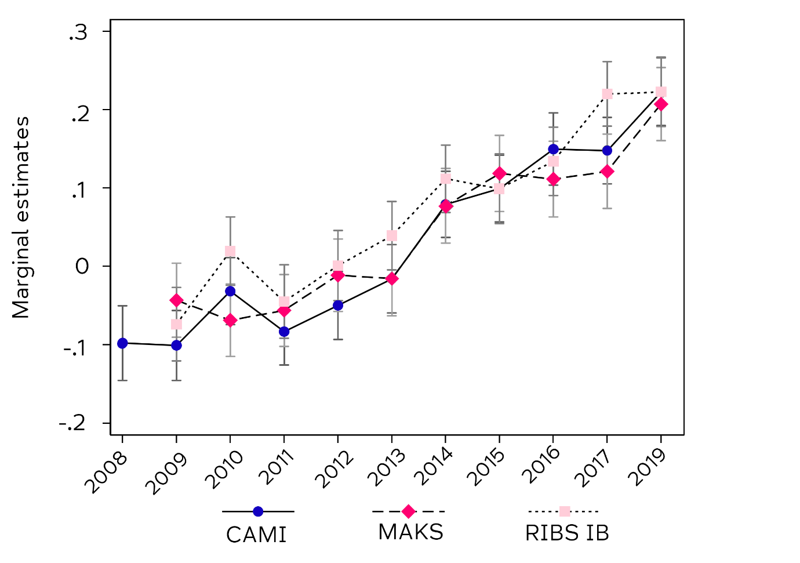Figure 1: What happened after a decade of Time to Change? (Source: AMI 2023, analysis by Institute of Psychiatry, Psychology, and Neuroscience, KCL.)

As Figure 1 shows, the period 2008 to 2019 saw consistent improvement in the headline measures of stigma in a nationally representative sample of adults in England. By 2019 Time to Change was able to confidently say that over 5 million adults had improved attitudes towards people with mental health problems when compared with 2008.

## 3. Results

### 3.1 Attitudes, behaviour, and knowledge

The 2023 wave of the Attitudes to Mental Illness survey provides the most up-to-date picture of mental health stigma in England available. Although comparisons between the 2021/2023 waves and the 2019 and earlier waves are complicated by the effects of data collection moving from face-to-face to self-completion, the changes are stark when placed in the context of the period since 2008/9.

#### There’s a worrying trend in public stigma

Figure 2 shows the overall picture at the national level of knowledge, attitudes, and behaviour – the 3 component parts of public stigma. Mental health-related knowledge and intended behaviour have strikingly fallen since 2019, while mental health attitudes have started to decline from 2021. Although the difference between 2021 and 2023 levels of attitudes is not statistically significant, the trend across all 3 measures is worrying.

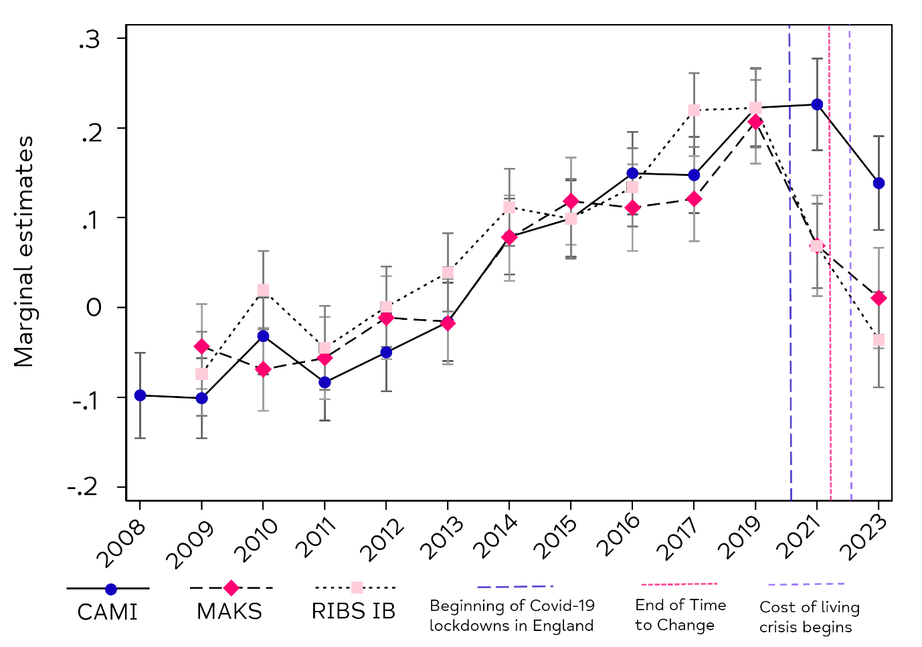Figure 2: What happened after Time to Change ended? (Source: AMI 2023, analysis by Institute of Psychiatry, Psychology, and Neuroscience, KCL.)

To put the results in comparative perspective, in 2019 there were statistically significant improvements in all 3 measures – that is, knowledge, attitudes, and behaviour – when compared with the starting points a decade earlier. Following falls in knowledge and behaviour since 2019 and in attitudes since 2021, knowledge and behaviour have returned to 2009 levels while attitudes are now equivalent with those from 2014. We at Mind feel that this is reason to be concerned about the possibility of backsliding and possible future worsening of mental health stigma.

### 3.2 What’s driving the marked decline in headline stigma measures?

The Attitudes to Mental Illness survey is designed primarily to identify change rather than to explain it. Nevertheless, the component items of the 3 scales provide useful insights into what is driving change at the national level in the 3 stigma measures.

#### There’s been a change in attitudes towards community care

Within the CAMI scale of attitudes, as shown by Figure 3, overall changes are being driven by a decrease in the tolerance and support for community care. Previous improvements in the prejudice and exclusion scale have in very large part remained. Given that the prejudice and exclusion scale is designed precisely to measure the level of prejudicial and exclusionary attitudes among adults in England, this is real reason for hope: the gains of over a decade of reducing prejudice around mental health have been maintained. What has changed is that English adults are now less likely to feel that the best therapy for many people with mental illness is to be part of a community or that mental health services should be provided through the community. Comparing 2019 and 2023, the decrease in the CAMI tolerance and support for community care scale is statistically significant.

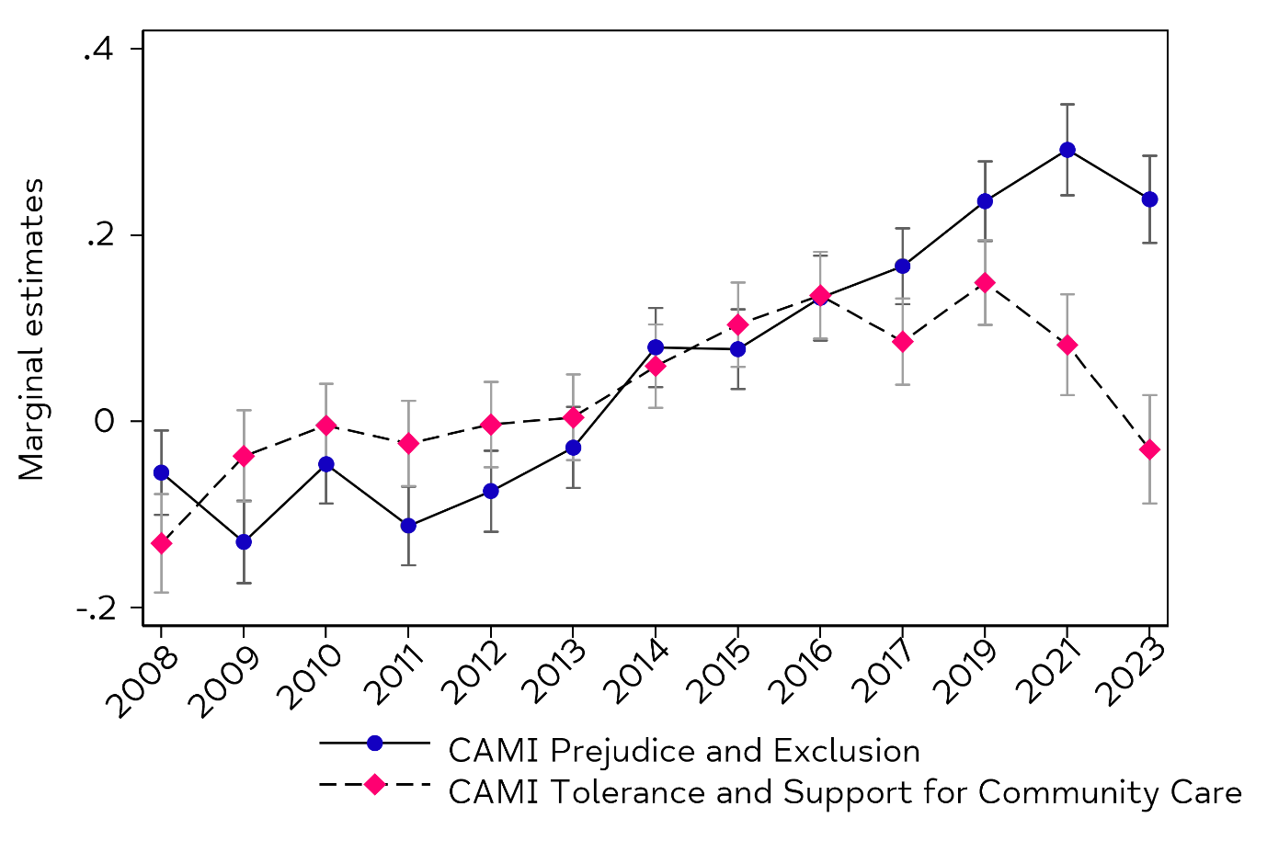Figure 3: What might be driving the marked decline in stigma measures? Comparison of the CAMI prejudice and exclusion and CAMI tolerance and support for community care subscales. (Source: AMI 2023, analysis by Institute of Psychiatry, Psychology, and Neuroscience, KCL.)

Within the MAKS scale, which measures knowledge, 2 items show a marked change between 2019 and 2023: ‘If a friend had a mental health problem, I know what advice to give them to get professional help’ (66.1% of respondents strongly or slightly agreeing in 2019 compared with 59.8% in 2023) and ‘People with severe mental health problems can fully recover’ (66.7% of respondents strongly or slightly agreeing in 2019 compared with 59.1% in 2023). In both cases, there seems to be increasing pessimism that help and support can be effective – particularly for people with less understood mental health problems.

Within the intended behaviour scale (RIBS-IB), change is being driven by the proportion of respondents strongly or slightly agreeing with the statements: ‘I would be willing to live with someone with mental health problems’ (69.3% of respondents strongly or slightly agreeing in 2019 compared with 55.0% in 2023) and ‘I would be willing to live nearby to someone with mental health problems’ (81.3% of respondents strongly or slightly agreeing in 2019 compared with 75.2% in 2023).

Overall, in relation to knowledge and attitudes, we might suggest that we are starting to see an increase in ‘therapeutic pessimism’, such that adults in England are less likely than before to believe that a community-based system of mental healthcare enables people with mental health problems to get better, to know how to help a friend get the right advice, or to think that recovery from a less well understood mental health problem is possible.

### 3.3 Mental health vignettes and workplace attitudes

#### Stigma around depression and schizophrenia

The 2023 wave of the Attitudes to Mental Illness also allows for an analysis of how the stigma around depression and schizophrenia may have changed over time through the introduction of 2 vignettes. These short accounts of the symptoms of 2 hypothetical individuals with mental health problems describe the experiences of ‘Stephen’” and ‘Andy’ but do not use the diagnostic labels ‘depression’ for Stephen or ‘schizophrenia’ for Andy (see Box 1 and Box 2). Having read the vignettes, respondents are then asked for their willingness or unwillingness to:

* Move next door to Stephen/Andy
* Spend time socialising with Stephen/Andy
* Make friends with Stephen/Andy
* Have Stephen/Andy as a workmate or colleague
* Have Stephen/Andy marry into the family
* Have Stephen/Andy provide childcare for someone in their family

#### Box 1: Stephen vignette (Source: AMI 2023)

Stephen has been feeling really down for about 6 months and his family have noticed that he hasn't been himself. He doesn't enjoy things the way he normally would. He wakes up early in the morning with a flat heavy feeling that stays with him all day long. He has to force himself to get through the day, and even the smallest things seem hard to do. He finds it hard to concentrate on anything and has no energy.

#### Box 2: Andy vignette (Source: AMI 2023)

Andy was doing pretty well until 6 months ago. But then things started to change. He thought that people around him were criticising him and talking behind his back. Andy heard voices even though no one else was around. These voices told him what to do and what to think. Andy couldn't work anymore, stopped joining in with family activities and started to spend most of the day in his room.

The vignette approach was also used in the British Social Attitudes Survey (BSAS) in 2007 and 2015. Although there are differences in samples between the AMI and BSAS, we can compare responses from England over time to give an indicative picture of change.

Figures 4 and 5: Mental health vignettes: Stephen (“depression”) and Andy (“schizophrenia”), compared with British Social Attitudes Survey 2007 and 2015. (Source: AMI 2023, analysis by Institute of Psychiatry, Psychology, and Neuroscience, KCL.)

Comparing 2007, 2015, and 2023, the vignettes show an increasing willingness to interact socially with both someone with symptoms associated with depression and someone with symptoms associated with schizophrenia. This increase is particularly marked in the case of someone with schizophrenia symptoms. The largest increase across any item is in the proportion of respondents willing to have someone with schizophrenia symptoms provide childcare for someone in their family, although this started from a low base.

The vignettes show a consistent, if narrowing, difference in the desire for social distance towards someone with schizophrenia symptoms and someone with depression symptoms. In other words, less common mental health problems still elicit a higher level of avoidance and shunning from adults in England, although things look to be improving. The biggest differences are in moving next door, marrying into the family, and providing childcare.[8]

#### Mental health stigma in the workplace

Finally, the Attitudes to Mental Illness 2023 survey also examined workplace attitudes. We can compare the 2023 findings with the British Social Attitudes Survey from 2015 for questions on perceived (Figure 6) and actual (Figure 7) stigma around diabetes (as a physical health point of comparison), depression, and schizophrenia.

As Figure 6 shows, perceived stigma has lessened for all 3 conditions when comparing 2023 with 2015. However, perceived stigma around schizophrenia is greater than that around diabetes. In other words, respondents are more likely to think that schizophrenia *will* affect someone’s likelihood of promotion when compared with diabetes.

Figure 7 illustrates that along with perceived stigma lessening for all 3 conditions when comparing 2023 with 2015, there is also no difference when comparing diabetes, depression, and schizophrenia in actual stigma. In other words, respondents are not more likely to think that schizophrenia *should* make a difference in the workplace when compared with depression or diabetes. 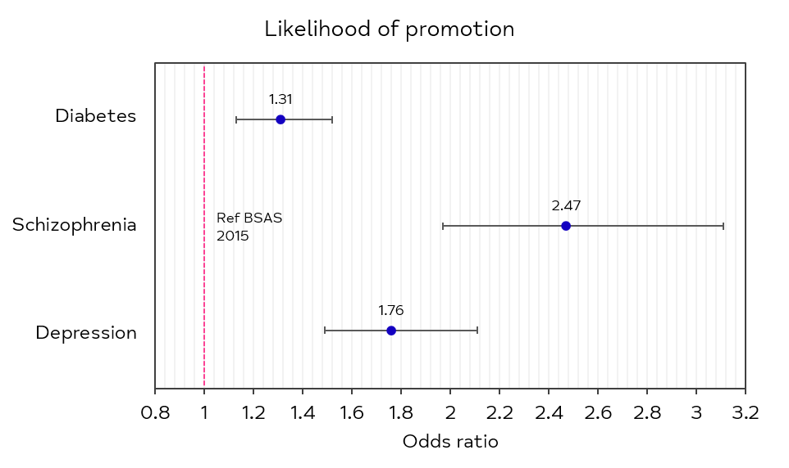

Figures 6 and 7: Perceived (Figure 6) and actual (Figure 7) stigma towards diabetes, schizophrenia, and depression in the workplace, compared with British Social Attitudes Survey 2015. (Source: AMI 2023, analysis by Institute of Psychiatry, Psychology, and Neuroscience, KCL.) 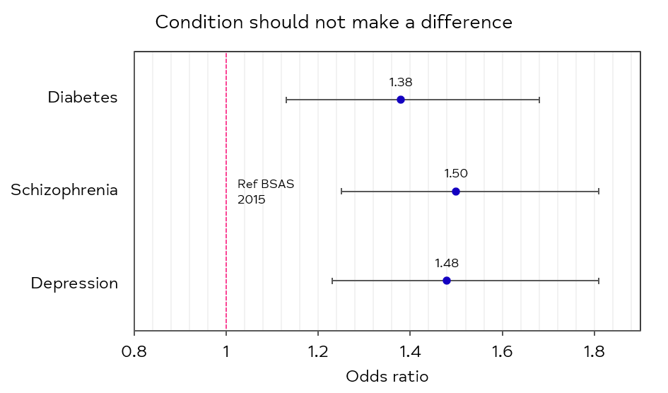

## 4. Discussion

Overall, the Attitudes to Mental Illness 2023 presents a complicated picture of change over time. Following a period of improvement, headline knowledge, attitudes, and behaviour measures fell from 2019/2021 to 2023. In the vignettes and workplace attitudes, however, we saw a decrease in stigma and a decrease in the desire for social distance when comparing 2023 with 2007 or 2015.

Although the underlying patterns of change reflect the complex reality of mental health today, they are likely the product of 2 main shifts since measurement of stigma started in England in 2008. The first is that as the COVID-19 era developed into a cost-of-living crisis and widespread economic anxiety, social attitudes towards mental health may have hardened.[9]

Second, the pathbreaking Time to Change national anti-stigma campaign in England, run by Mind and Rethink Mental Illness, wrapped up in 2021. We may now be in a situation where awareness is high but activity specifically targeting stigma is lower than during the period when Time to Change operated.

A comprehensive analysis by The *Lancet* Commission on Ending Mental Health Stigma and Discrimination of 216 systematic reviews summarised the evidence: what works in tackling stigma is people with lived experience, including of more complex mental health problems, sharing their stories face-to-face.[10] This ‘social contact’ intervention is the reverse of the shunning many people with mental health problems experience.

Without Time to Change, social contact activities have been harder to organise and deliver at the level needed to continue improving the stigma towards mental health. It should be noted that England is the only nation in the UK not to have a national anti-stigma campaign, with campaigns in Wales and Scotland both receiving government funding.[11]

In Wales, Time to Change Wales is now in its 4th funding cycle focussing specifically on the stigma experienced by racialised communities and those experiencing poverty. The Welsh government mental health strategy, currently awaiting publication at time of writing, contains multiple references to stigma, including in the overall vision for mental health in Wales. This includes commitments to people living free from stigma and discrimination, the need to continue to tackle stigma and views associated with poor mental health and to build on the action already in place to tackling stigma both within the public and within services.

### Positive changes have been maintained

While the picture of stigma today is not a simple one, particularly when compared to the changes between 2008/9 and 2019 and the period of the Time to Change campaign, it does seem that important achievements have been maintained. Specifically, decreases in prejudice and exclusion (as measured by the CAMI prejudice and exclusion subscale), a closing of the gap of stigma around schizophrenia and depression (as measured by the Stephen/Andy vignettes), and treatment in the workplace all seem to have held or continued improvements when comparing 2023 with previous data points. In other words, even in the face of the COVID-19 pandemic and economic upheaval, there seems to be a lower level of prejudice and desire for exclusion among adults in England when faced with a concrete example of someone with a mental health problem. This is reason for optimism.

### Economic and political impacts on stigma

On the other hand, some aspects of the stigma of mental illness seem to have increased since 2019/21. Items on the CAMI subscale of attitudes relating to tolerance and support for community care, along with knowledge items relating to access to treatment, seem not to have been immune to the effects of the COVID-19 pandemic and the cost of living crisis. These changes suggest that attitudes towards mental illness do not exist in a political or social vacuum, and are closely related to overall perceptions of the efficacy and availability of services. Although it remains to be seen, it is possible that stigma might reduce once the economic situation improves and access to treatment improves, although it is unclear if this improvement in stigma is likely without a national programme of social contact (such as Time to Change).

## 5. Conclusion

If the stigma around mental illness worsens, things for people with a mental health problem get harder. Worsening stigma means friends and family are more likely to avoid people with mental health problems, leading to increased social exclusion and isolation. Increased public stigma – as measured by the Attitudes to Mental Illness survey – is closely related to self-stigma, or feelings of shame. These feelings of shame can in turn lead to people feeling unworthy of getting the treatment they deserve, or of turning away from social interactions. As the Scottish Mental Illness Stigma Study found, experiences of discrimination and unfair treatment can lead to increased anticipated discrimination and further withdrawal on the part of people with mental health problems.[12] In other words, the results reported here can have serious real world consequences.

At Mind, we believe no-one should be treated unfairly because of a mental health problem. We are concerned that key measures of the stigma around mental health look like they are starting to move in the wrong direction in England. We are continuing to deliver Time to Change Wales, which focuses on people facing poverty and from racialised communities.

### What can be done?

#### The new UK government must act to address the growing mental health crisis

We are calling on the new UK government to take seriously our finding that stigma in England is at risk of worsening. We believe tackling stigma is foundational to any improvements in the nation’s mental health. Replacing stigma with respect is a precursor to wider changes. If mental health problems are a source of ignorance, prejudice, discrimination, and shame, then we will not have the investment in our mental healthcare system – or the service uptake – that we need to be a mentally healthy nation. And the voices of people with lived experience must be central to any discussion of the lived reality of stigma and how we should move away from stigma to being a mentally healthy nation.

#### We’ll continue to fight for support and respect

For our own part, through our network of over 100 local Minds, we will continue to deliver a wide range of anti-stigma interventions in communities across England and Wales. In Wales we are in the final year of funding for Time to Change Wales so we will be using the experience in England and the findings from the attitudes survey in Wales to make a case for continued funding. The mental health strategy provides an opportunity to continue to place stigma at the centre of the political and public debate around mental health, which will enable Mind Cymru to continue to have a platform to drive improvements.

In responding to these findings we have also refreshed our Media Advisory Service. Mind’s Media Advisory Service supports producers, researchers, programme makers and actors on how to depict mental health accurately and responsibly whether that’s in dramas or on factual programmes and documentaries. We put those with lived experience in touch with the actors playing them. We run workshops. We advise on what a mental health problem really feels like from the point of view of those of us who manage them every day. We will also continue to provide information on mental health to combat stigma. We hear from our supporters, campaigners, and members that they are determined to tackle mental health stigma and discrimination. We are too. We hope this research reignites the conversation around mental health stigma in England.

## Glossary

### Actual stigma

Actual stigma is compared in the Attitudes to Mental Illness research with perceived stigma. Actual stigma is measured as the extent to which a respondent believes that a given condition (depression, schizophrenia, or diabetes) *should* matter in a workplace context for someone’s likelihood of promotion.

### Attitudes

In the Attitudes to Mental Illness research, (mental health-related) attitudes are understood as 1 of the 3 domains of public stigma (along with behaviour and knowledge). Poor attitudes towards mental illness are understood as constituting a social problem of prejudice. Attitudes are measured through the Community Attitudes to Mental Illness (CAMI) scale.

### Behaviour

In the Attitudes to Mental Illness research, (mental health-related) behaviour is understood as 1 of the 3 domains of public stigma (along with attitudes and knowledge). Poor behaviour towards mental illness is understood as constituting a social problem of discrimination. Behaviour is measured through the Reported and Intended Behaviour Scale (RIBS).

### Community Attitudes to Mental Illness (CAMI)

Community Attitudes to Mental Illness is a social psychological tool developed to measure attitudes towards mental illness at the community or national level. By asking respondents about their agreement with 27 attitude statements, the CAMI scale is able to measure 2 aspects of attitudes towards mental illness:

* The extent to which respondents hold prejudicial or exclusionary attitudes
* The extent to which respondents are tolerant and support community care for people with mental health problems

An example of an attitude statement that measures prejudice / exclusion is “People with mental health problems don’t deserve our sympathy” while an example of an attitudes statement that measures tolerance and support for community care is “No-one has the right to exclude people with mental health from their community”. Respondents are asked the extent to which they agree with the attitude statements, ranging from “strongly agree” to “strongly disagree”. Respondents score more highly on the CAMI scale the less prejudicial and the more tolerant their attitudes are.

### Intended behaviour

Intended behaviour is understood in the Attitudes to Mental Illness research as the behaviour towards people with mental health problems that respondents intend to perform in the future. It is compared with reported behaviour (which is the behaviour respondents report as already having performed with relation to people with mental health problems). Intended behaviour is measured through the Reported and Intended Behaviour Scale (RIBS) by asking respondents’ willingness to live with, work with, live nearby, and continue a relationship with a friend with mental health problems.

### Knowledge

In the Attitudes to Mental Illness research, (mental health-related) knowledge is understood as 1 of the 3 domains of public stigma (along with behaviour and knowledge). Poor knowledge about mental illness is understood as constituting a social problem of ignorance. Mental health-related knowledge is measured through the Mental Health Knowledge Schedule (MAKS) scale.

### Mental Health Knowledge Schedule (MAKS)

The Mental Health Knowledge Schedule is a social psychological tool developed to measure knowledge about mental health and mental illness at the community or national level. The Mental Health Knowledge Schedule asks respondents whether 6 factual statements about mental illness are true or false and then whether 6 conditions (depression, stress, schizophrenia, bipolar disorder, drug addiction, and grief) are mental health problems.

An example of a factual statement is “Most people with mental health problems want to have paid employment” (which is true). Not all factual statements are true. Respondents score more highly on the MAKS scale the more factual statements they correctly identify as true or false and the greater number of conditions they correctly identify as mental health problems.

### Perceived stigma

Perceived stigma is compared in the Attitudes to Mental Illness research with actual stigma. Perceived stigma is measured as the extent to which a respondent believes that a given condition (depression, schizophrenia, or diabetes) *does in fact* matter in a workplace context for someone’s likelihood of promotion.

### Reported and Intended Behaviour Scale (RIBS)

The Reported and Intended Behaviour Scale is a social psychological tool developed to measure behaviour towards people with mental health problems at the community or national level. The Reported and Intended Behaviour Scale asks respondents 8 questions relating to their behaviour towards people with mental health problems. Reported behaviour is measured by asking respondents whether they *do* live with, work with, live nearby, or have a close friend with a mental health problem. Intended behaviour is instead measured by asking respondents whether they *would* live with, work with, live nearby, or continue a relationship with a friend with a mental health problem.

1. For example, The *Lancet* Commission on Ending Stigma and Discrimination in Mental Health (2022) found that 80% of 391 respondents to a global survey of people with lived experience agreed or strongly agreed with the statement ‘Stigma and discrimination can be worse than the impact of the mental health condition itself’. See Thornicroft et al (2022), *The Lancet Commission on Ending Stigma and Discrimination*, available at: <https://www.thelancet.com/journals/lancet/article/PIIS0140-6736(22)01470-2/>.
2. On stigma as a barrier for help-seeking behaviour, see Henderson et al (2013), ‘Mental illness stigma, help seeking, and public health programs’, *American Journal of Public Health*; available at: <https://www.ncbi.nlm.nih.gov/pmc/articles/PMC3698814/>. 
3. Available at: https://www.medrxiv.org/content/10.1101/2024.02.20.24303075v1. The full Attitudes to Mental Illness 2023 report is available on request from Mind.
4. See for instance Thornicroft et al (2007), ‘Stigma: ignorance, prejudice or discrimination?’, available at: <https://www.cambridge.org/core/journals/the-british-journal-of-psychiatry/article/stigma-ignorance-prejudice-or-discrimination/E6F23CE48666A53C8E99870F0474E1AA>.
5. In both cases respondents are asked for their level of agreement with the statements (using a 5-point Likert scale), with less stigmatising attitudes being coded as higher scores within the CAMI scale.
6. See *Lancet* Commission on Ending Stigma and Discrimination in Mental Health (2022) for more on the evidence base around social contact.
7. See Henderson et al (2020), ‘Mental illness stigma after a decade of Time to Change England’; available at: <https://pubmed.ncbi.nlm.nih.gov/32531039/>.
8. For moving next door, 89.8% of respondents were willing when asked about someone with depression symptoms, compared with 78.2% when asked about someone with schizophrenia symptoms, a difference of 11.6%. For marrying into the family, 80.0% of respondents were willing when asked about someone with depression symptoms, compared with 72.1% when asked about someone with schizophrenia symptoms, a difference of 7.9%. And, for providing childcare, 60.8% of respondents were willing when asked about someone with depression symptoms, compared with 41.5% when asked about someone with schizophrenia symptoms, a difference of 19.3%. For comparison, the differences in the BSAS 2007 were 19% for moving next door, 15.6% for marrying into the family, and 13.6% for providing childcare.
9. Time to Change Wales have commissioned a tracking survey looking at the trend around stigma in Wales, allowing us to see what the impact of these wider societal levers has been and whether this is consistent with what we have seen in England.
10. See The *Lancet* Commission on Ending Stigma and Discrimination in Mental Health (2022), available at: <https://www.thelancet.com/journals/lancet/article/PIIS0140-6736(22)01470-2/>.
11. While Time to Change Wales and See Me in Scotland receive government funding, Inspire in Northern Ireland does not.
12. See Ewens et al (2022), *The Scottish Mental Illness Stigma Study: Final Report*, The Mental Health Foundation and See Me; available at: <https://www.seemescotland.org/media/11118/see-me-scottish-mental-illness-stigma-study-final-report-sep-2022.pdf>.